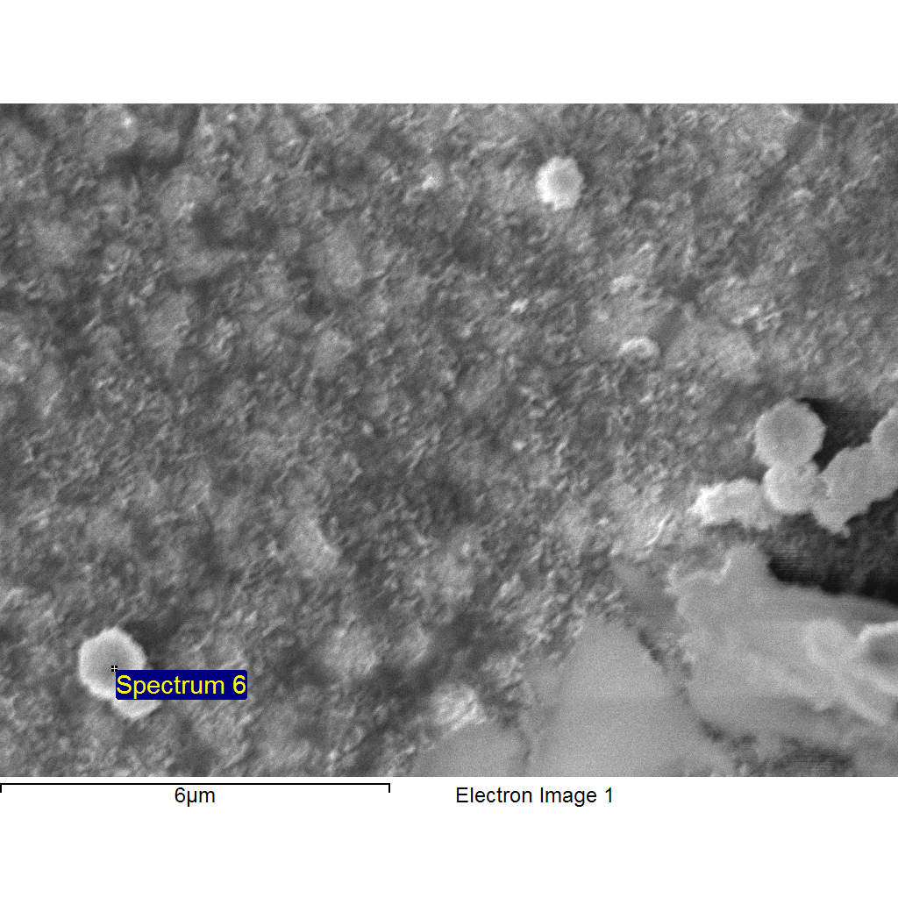
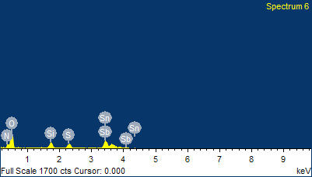

Project 1
1/17/2012 2:55:36 PM
Sample: Sample 1
Type: Default
ID: anneal sta

Comment:
Spectrum processing :
No peaks omitted

Processing option : All elements analyzed (Normalised)
Number of iterations = 2

Standard :
N Not defined 1-Jun-1999 12:00 AM
O SiO2 1-Jun-1999 12:00 AM
Si SiO2 1-Jun-1999 12:00 AM
S FeS2 1-Jun-1999 12:00 AM
Sn Sn 1-Jun-1999 12:00 AM
Sb Sb 1-Jun-1999 12:00 AM

Element | App | Intensity | Weight% | Weight% | Atomic%
 | Conc. | Corrn. |  | Sigma
N K | 0.00 | 0.7724 | 0.00 | 0.00 | 0.00
O K | 0.51 | 1.0684 | 30.67 | 1.35 | 70.14
Si K | 0.08 | 1.1589 | 4.60 | 0.35 | 5.99
S K | 0.09 | 1.1756 | 4.81 | 0.41 | 5.49
Sn L | 0.60 | 0.8216 | 46.70 | 1.63 | 14.40
Sb L | 0.17 | 0.8157 | 13.22 | 1.82 | 3.97
Totals |  |  | 100.00

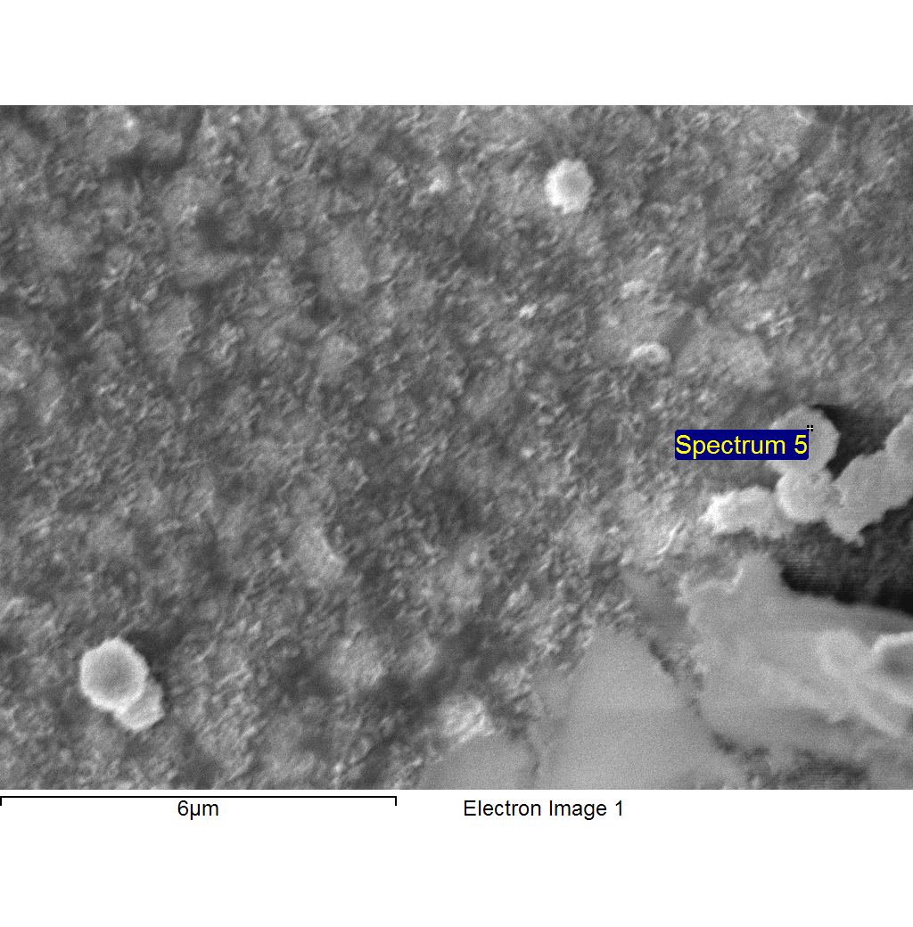
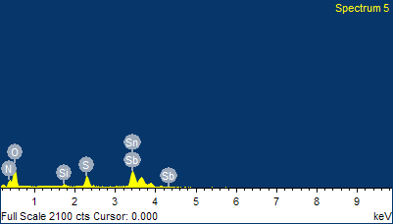
Project 1
1/17/2012 2:55:44 PM
Sample: Sample 1
Type: Default
ID: anneal sta

Comment:
Spectrum processing :
No peaks omitted

Processing option : All elements analyzed (Normalised)
Number of iterations = 2

Standard :
N Not defined 1-Jun-1999 12:00 AM
O SiO2 1-Jun-1999 12:00 AM
Si SiO2 1-Jun-1999 12:00 AM
S FeS2 1-Jun-1999 12:00 AM
Sn Sn 1-Jun-1999 12:00 AM
Sb Sb 1-Jun-1999 12:00 AM

Element | App | Intensity | Weight% | Weight% | Atomic%
 | Conc. | Corrn. |  | Sigma
N K | 0.00 | 0.7936 | 0.00 | 0.00 | 0.00
O K | 0.60 | 0.9973 | 21.63 | 0.95 | 62.06
Si K | 0.03 | 1.1846 | 0.87 | 0.17 | 1.42
S K | 0.22 | 1.2318 | 6.43 | 0.34 | 9.21
Sn L | 1.30 | 0.8642 | 53.73 | 1.31 | 20.78
Sb L | 0.42 | 0.8589 | 17.34 | 1.40 | 6.54
Totals |  |  | 100.00

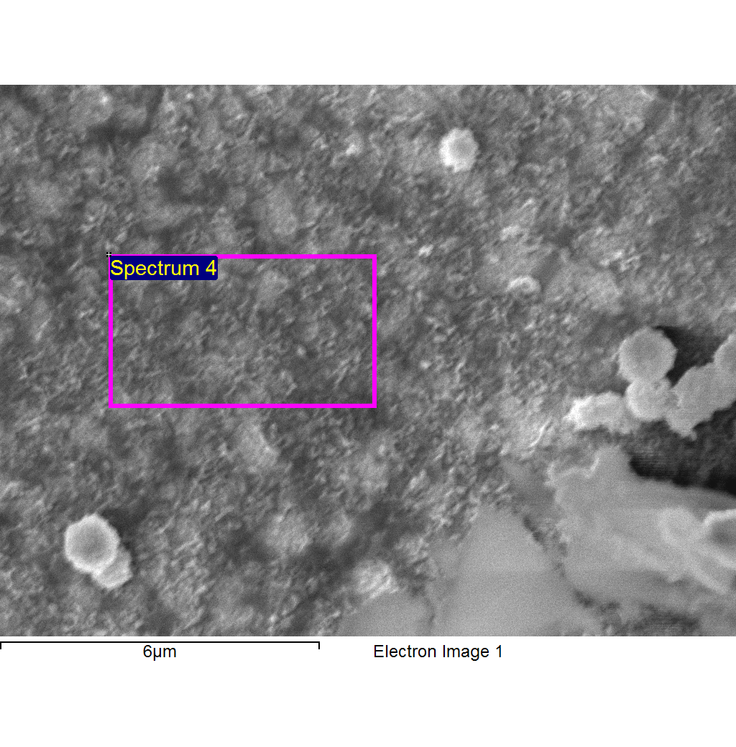
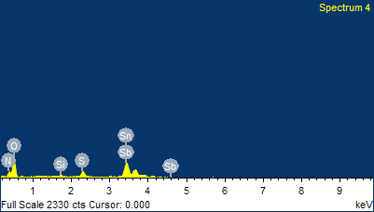
Project 1
1/17/2012 2:55:50 PM
Sample: Sample 1
Type: Default
ID: anneal sta

Comment:
Spectrum processing :
No peaks omitted

Processing option : All elements analyzed (Normalised)
Number of iterations = 2

Standard :
N Not defined 1-Jun-1999 12:00 AM
O SiO2 1-Jun-1999 12:00 AM
Si SiO2 1-Jun-1999 12:00 AM
S FeS2 1-Jun-1999 12:00 AM
Sn Sn 1-Jun-1999 12:00 AM
Sb Sb 1-Jun-1999 12:00 AM

Element | App | Intensity | Weight% | Weight% | Atomic%
 | Conc. | Corrn. |  | Sigma
N K | 0.00 | 0.8364 | 0.00 | 0.00 | 0.00
O K | 0.65 | 0.9295 | 25.14 | 1.02 | 67.62
Si K | 0.03 | 1.1767 | 0.99 | 0.18 | 1.52
S K | 0.14 | 1.2215 | 4.25 | 0.30 | 5.71
Sn L | 1.43 | 0.8577 | 59.93 | 1.38 | 21.73
Sb L | 0.23 | 0.8519 | 9.68 | 1.49 | 3.42
Totals |  |  | 100.00

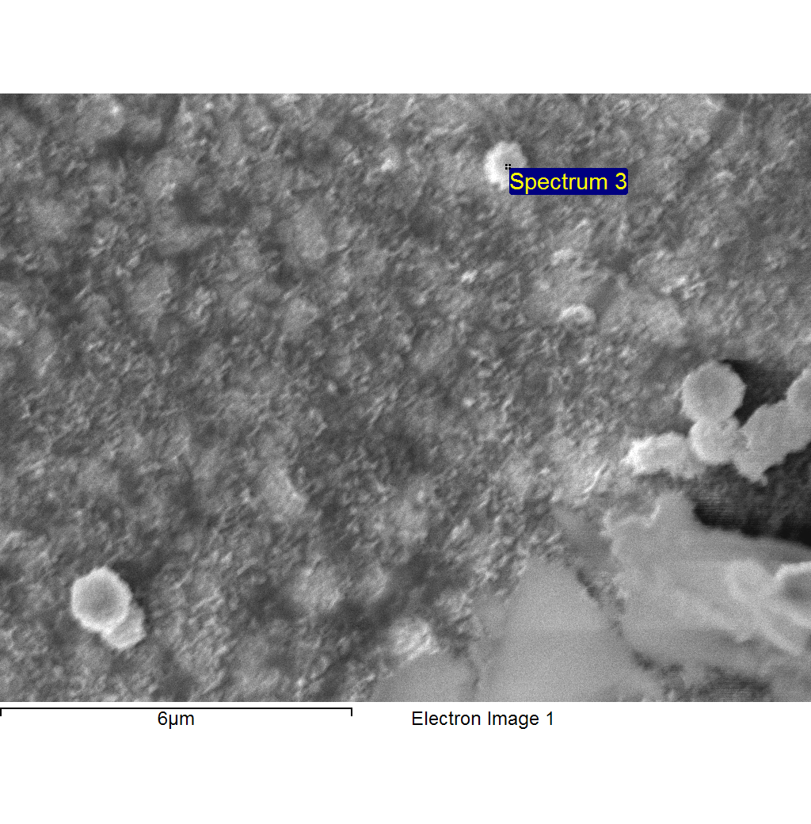
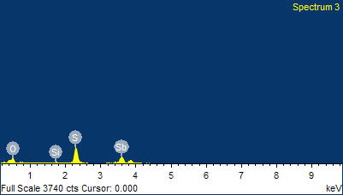
Project 1
1/17/2012 2:55:58 PM
Sample: Sample 1
Type: Default
ID: anneal sta

Comment:
Spectrum processing :
No peaks omitted

Processing option : All elements analyzed (Normalised)
Number of iterations = 2

Standard :
O SiO2 1-Jun-1999 12:00 AM
Si SiO2 1-Jun-1999 12:00 AM
S FeS2 1-Jun-1999 12:00 AM
Sb Sb 1-Jun-1999 12:00 AM

Element | App | Intensity | Weight% | Weight% | Atomic%
 | Conc. | Corrn. |  | Sigma
O K | 0.36 | 2.1041 | 7.84 | 0.51 | 26.78
Si K | 0.02 | 1.2086 | 0.85 | 0.22 | 1.66
S K | 0.67 | 1.2455 | 24.36 | 0.69 | 41.51
Sb L | 1.25 | 0.8504 | 66.95 | 0.87 | 30.05
Totals |  |  | 100.00

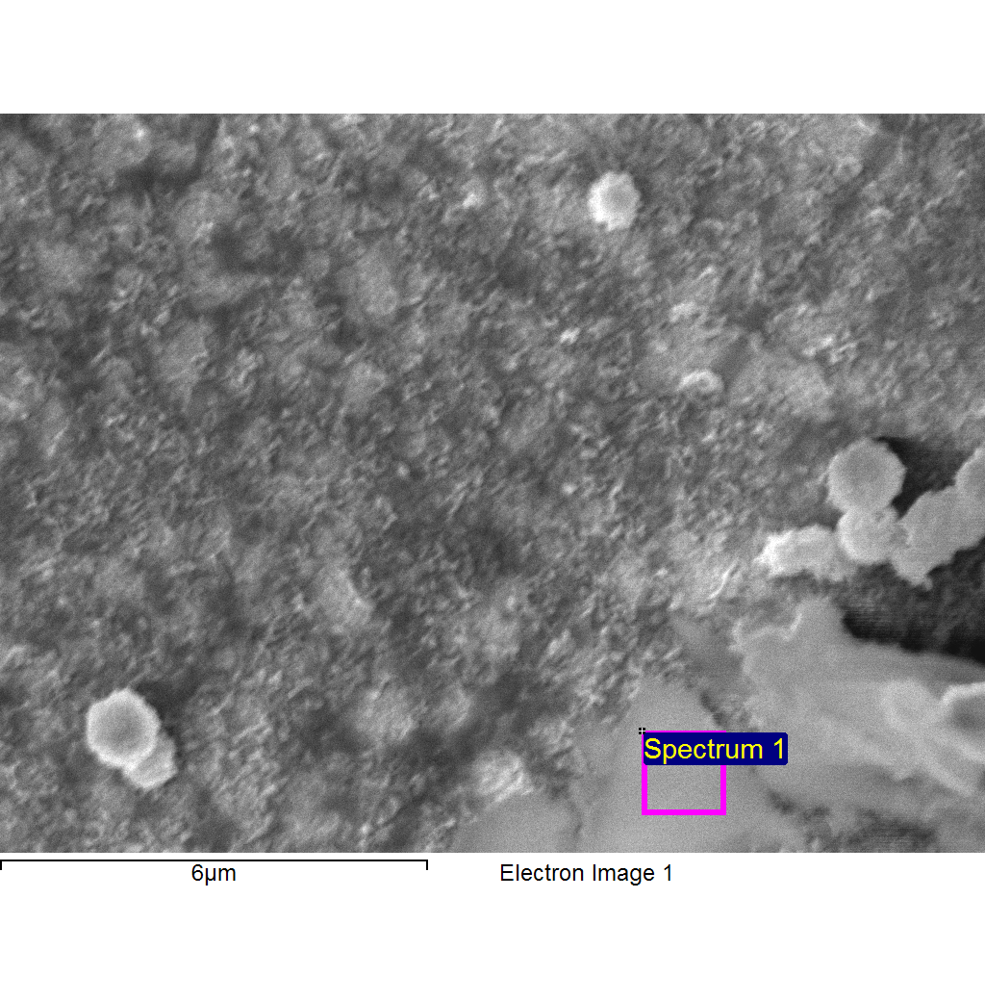
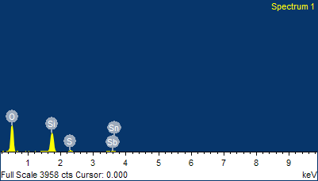
Project 1
1/17/2012 2:56:06 PM
Sample: Sample 1
Type: Default
ID: anneal sta

Comment:
Spectrum processing :
No peaks omitted

Processing option : All elements analyzed (Normalised)
Number of iterations = 2

Standard :
O SiO2 1-Jun-1999 12:00 AM
Si SiO2 1-Jun-1999 12:00 AM
S FeS2 1-Jun-1999 12:00 AM
Sn Sn 1-Jun-1999 12:00 AM
Sb Sb 1-Jun-1999 12:00 AM

Element | App | Intensity | Weight% | Weight% | Atomic%
 | Conc. | Corrn. |  | Sigma
O K | 2.26 | 1.6652 | 55.06 | 1.02 | 74.56
Si K | 0.72 | 1.0979 | 26.78 | 0.63 | 20.66
S K | 0.07 | 0.9874 | 3.02 | 0.28 | 2.04
Sn L | 0.16 | 0.6877 | 9.16 | 0.96 | 1.67
Sb L | 0.10 | 0.6813 | 5.97 | 1.04 | 1.06
Totals |  |  | 100.00

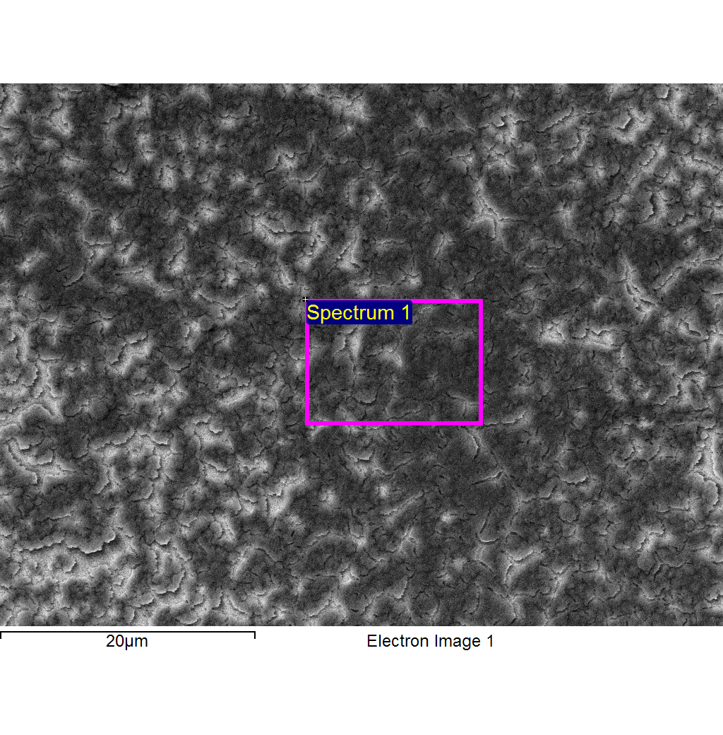
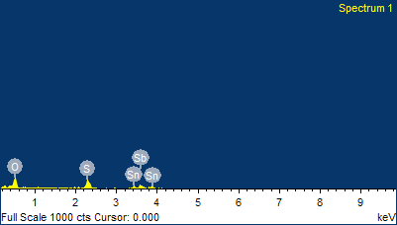
Project 1
1/17/2012 3:20:45 PM
Sample: Sample 2
Type: Default
ID: sta

Comment:
Spectrum processing :
No peaks omitted

Processing option : All elements analyzed (Normalised)
Number of iterations = 2

Standard :
O SiO2 1-Jun-1999 12:00 AM
S FeS2 1-Jun-1999 12:00 AM
Sn Sn 1-Jun-1999 12:00 AM
Sb Sb 1-Jun-1999 12:00 AM

Element | App | Intensity | Weight% | Weight% | Atomic%
 | Conc. | Corrn. |  | Sigma
O K | 6.68 | 2.0090 | 12.00 | 1.36 | 42.08
S K | 5.01 | 1.3695 | 13.19 | 1.31 | 23.09
Sn L | 7.01 | 0.8709 | 29.01 | 3.57 | 13.72
Sb L | 10.96 | 0.8632 | 45.80 | 3.70 | 21.11
Totals |  |  | 100.00

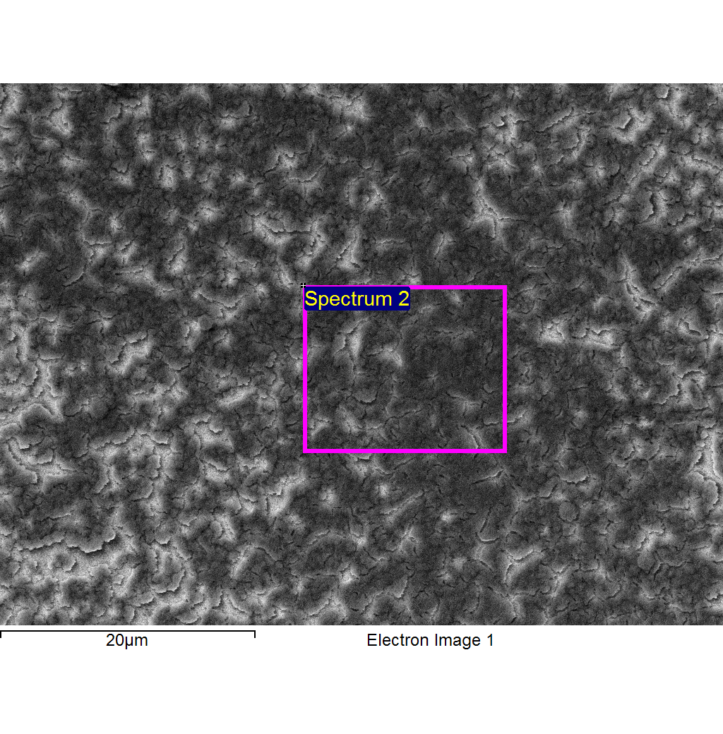
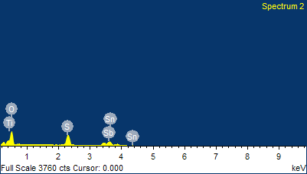
Project 1
1/17/2012 3:20:52 PM
Sample: Sample 2
Type: Default
ID: sta

Comment:
Spectrum processing :
No peaks omitted

Processing option : All elements analyzed (Normalised)
Number of iterations = 3

Standard :
O SiO2 1-Jun-1999 12:00 AM
S FeS2 1-Jun-1999 12:00 AM
Ti Ti 1-Jun-1999 12:00 AM
Sn Sn 1-Jun-1999 12:00 AM
Sb Sb 1-Jun-1999 12:00 AM

Element | App | Intensity | Weight% | Weight% | Atomic%
 | Conc. | Corrn. |  | Sigma
O K | 19.70 | 2.0081 | 12.76 | 0.53 | 43.68
S K | 13.97 | 1.3638 | 13.33 | 0.52 | 22.75
Ti K | 0.00 | 1.0921 | 0.00 | 0.00 | 0.00
Sn L | 19.15 | 0.8663 | 28.75 | 1.45 | 13.26
Sb L | 29.81 | 0.8585 | 45.16 | 1.48 | 20.31
Totals |  |  | 100.00

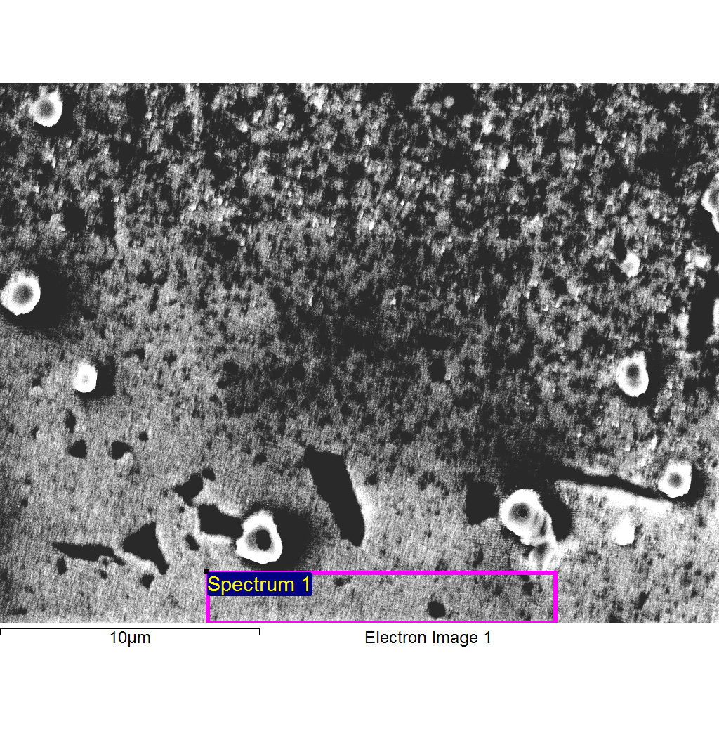
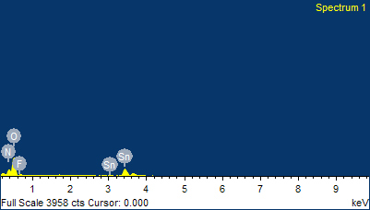
Project 1
1/17/2012 3:34:34 PM
Sample: Sample 3
Type: Default
ID: non sta

Comment:
Spectrum processing :
No peaks omitted

Processing option : All elements analyzed (Normalised)
Number of iterations = 3

Standard :
N Not defined 1-Jun-1999 12:00 AM
O SiO2 1-Jun-1999 12:00 AM
F MgF2 1-Jun-1999 12:00 AM
Sn Sn 1-Jun-1999 12:00 AM

Element | App | Intensity | Weight% | Weight% | Atomic%
 | Conc. | Corrn. |  | Sigma
N K | 0.00 | 1.1254 | 0.00 | 0.00 | 0.00
O K | 22.93 | 1.3340 | 27.04 | 0.84 | 73.33
F K | 0.00 | 0.6613 | 0.00 | 0.00 | 0.00
Sn L | 39.23 | 0.8459 | 72.96 | 0.84 | 26.67
Totals |  |  | 100.00

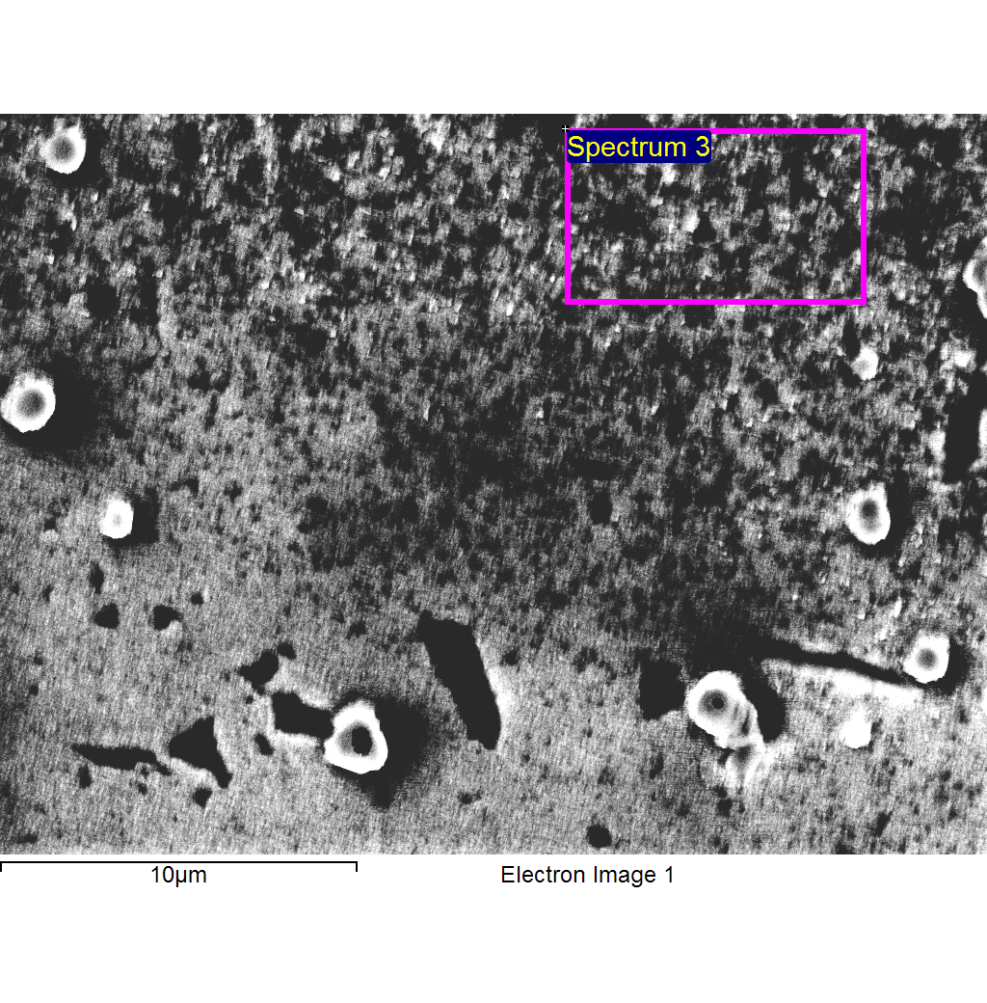
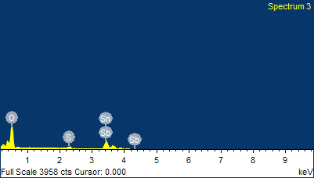
Project 1
1/17/2012 3:34:40 PM
Sample: Sample 3
Type: Default
ID: non sta

Comment:
Spectrum processing :
No peaks omitted

Processing option : All elements analyzed (Normalised)
Number of iterations = 3

Standard :
O SiO2 1-Jun-1999 12:00 AM
S FeS2 1-Jun-1999 12:00 AM
Sn Sn 1-Jun-1999 12:00 AM
Sb Sb 1-Jun-1999 12:00 AM

Element | App | Intensity | Weight% | Weight% | Atomic%
 | Conc. | Corrn. |  | Sigma
O K | 34.81 | 1.4509 | 25.57 | 0.83 | 70.35
S K | 2.66 | 1.3269 | 2.13 | 0.23 | 2.93
Sn L | 50.11 | 0.8451 | 63.19 | 1.43 | 23.43
Sb L | 7.14 | 0.8362 | 9.10 | 1.71 | 3.29
Totals |  |  | 100.00

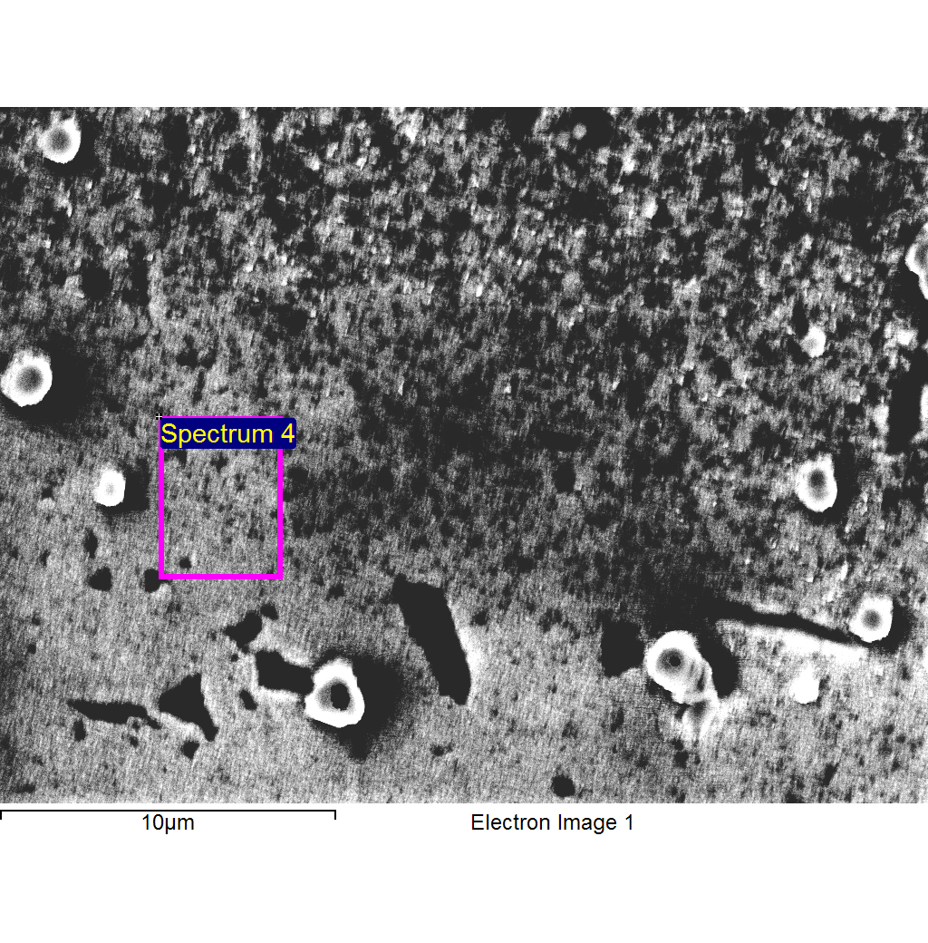
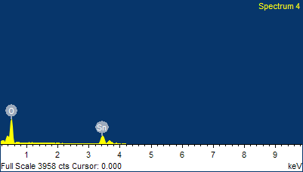
Project 1
1/17/2012 3:34:46 PM
Sample: Sample 3
Type: Default
ID: non sta

Comment:
Spectrum processing :
No peaks omitted

Processing option : All elements analyzed (Normalised)
Number of iterations = 3

Standard :
O SiO2 1-Jun-1999 12:00 AM
Sn Sn 1-Jun-1999 12:00 AM

Element | App | Intensity | Weight% | Weight% | Atomic%
 | Conc. | Corrn. |  | Sigma
O K | 35.11 | 1.3393 | 27.61 | 0.70 | 73.88
Sn L | 57.95 | 0.8431 | 72.39 | 0.70 | 26.12
Totals |  |  | 100.00

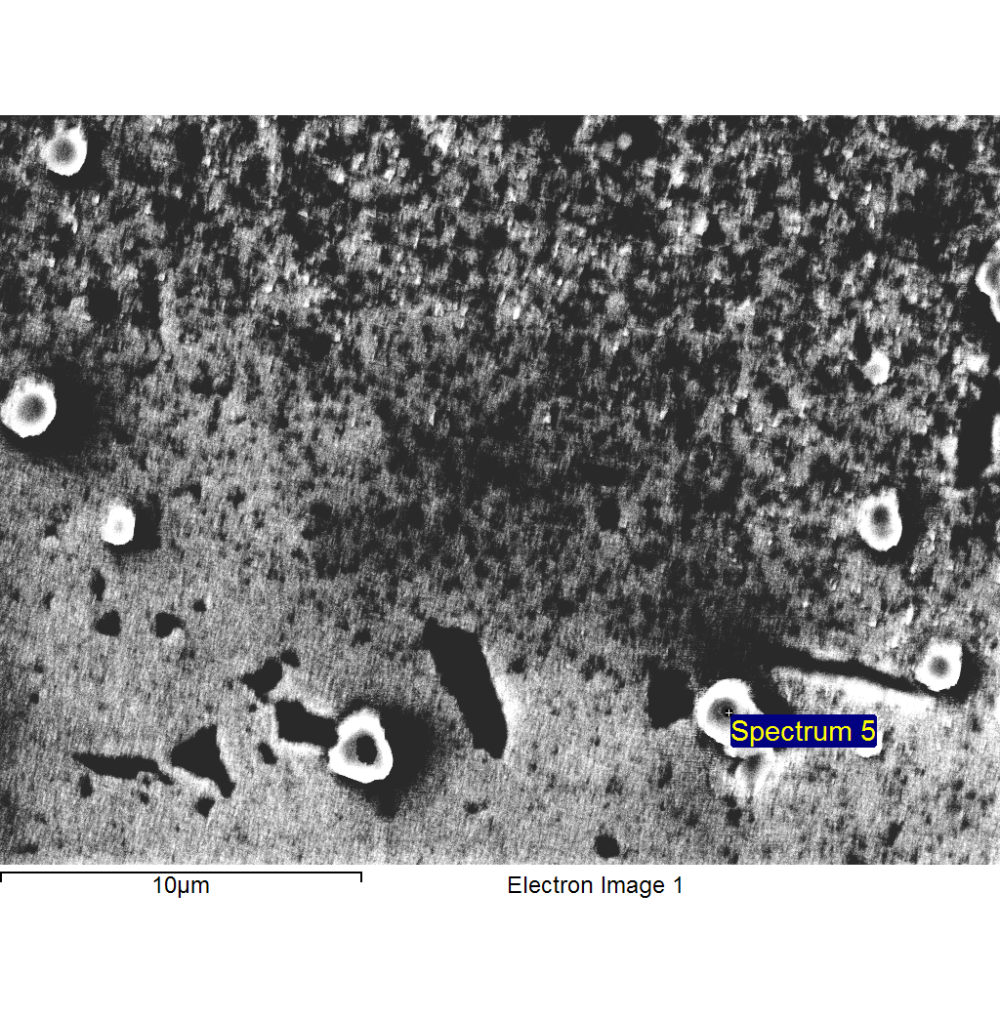
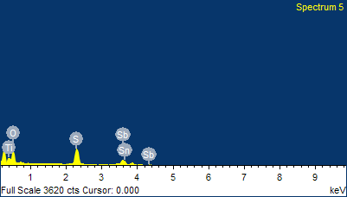
Project 1
1/17/2012 3:34:52 PM
Sample: Sample 3
Type: Default
ID: non sta

Comment:
Spectrum processing :
No peaks omitted

Processing option : All elements analyzed (Normalised)
Number of iterations = 3

Standard :
O SiO2 1-Jun-1999 12:00 AM
S FeS2 1-Jun-1999 12:00 AM
Ti Ti 1-Jun-1999 12:00 AM
Sn Sn 1-Jun-1999 12:00 AM
Sb Sb 1-Jun-1999 12:00 AM

Element | App | Intensity | Weight% | Weight% | Atomic%
 | Conc. | Corrn. |  | Sigma
O K | 16.02 | 2.3871 | 10.32 | 0.51 | 34.71
S K | 18.12 | 1.3486 | 20.66 | 0.78 | 34.67
Ti K | 0.00 | 1.0767 | 0.00 | 0.00 | 0.00
Sn L | 5.97 | 0.8494 | 10.80 | 1.68 | 4.90
Sb L | 31.88 | 0.8421 | 58.21 | 1.56 | 25.72
Totals |  |  | 100.00

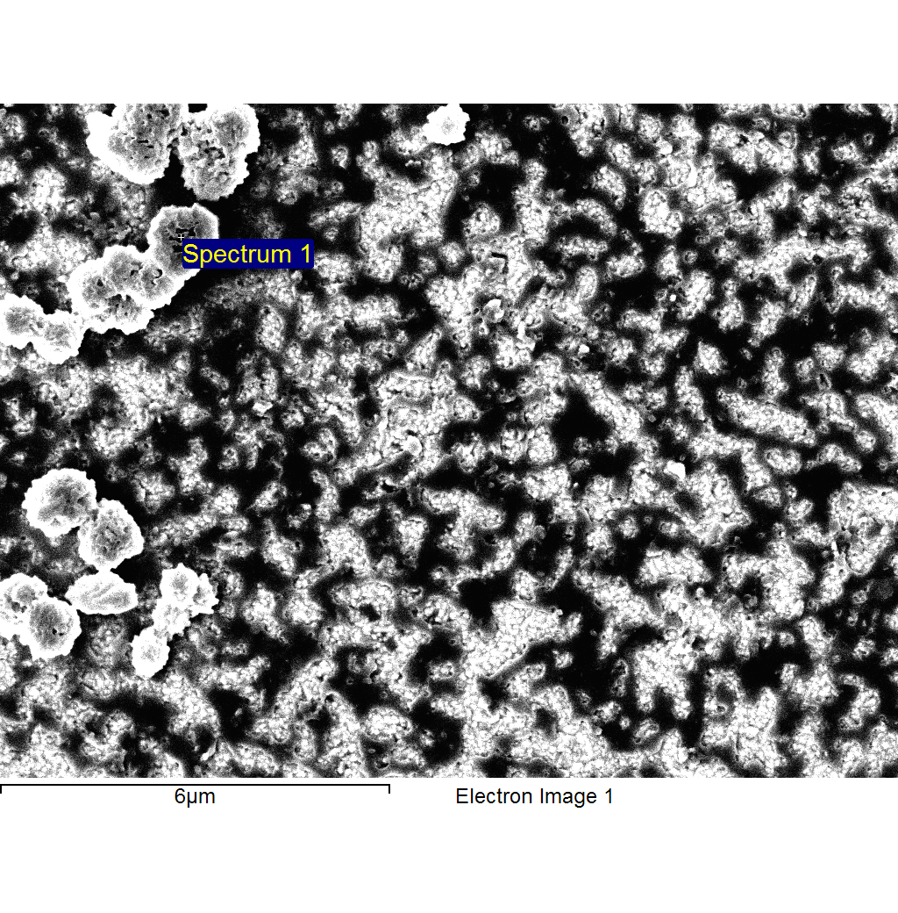
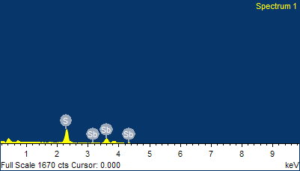
Project 1
1/17/2012 3:52:46 PM
Sample: Sample 4
Type: Default
ID: anneal non sta

Comment:
Spectrum processing :
No peaks omitted

Processing option : All elements analyzed (Normalised)
Number of iterations = 3

Standard :
S FeS2 1-Jun-1999 12:00 AM
Sb Sb 1-Jun-1999 12:00 AM

Element | App | Intensity | Weight% | Weight% | Atomic%
 | Conc. | Corrn. |  | Sigma
S K | 7.45 | 1.4189 | 20.93 | 1.07 | 50.13
Sb L | 17.78 | 0.8969 | 79.07 | 1.07 | 49.87
Totals |  |  | 100.00

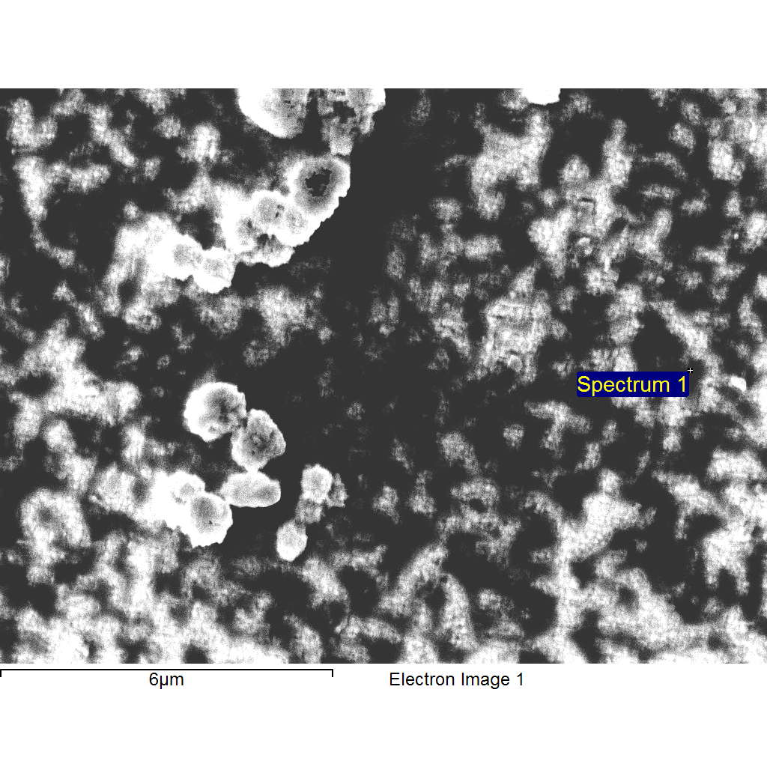
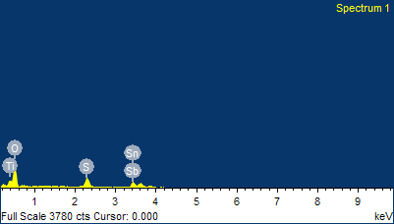
Project 1
1/17/2012 3:58:35 PM
Sample: Sample 5
Type: Default
ID: anneal nonsta

Comment:
Spectrum processing :
No peaks omitted

Processing option : All elements analyzed (Normalised)
Number of iterations = 3

Standard :
O SiO2 1-Jun-1999 12:00 AM
S FeS2 1-Jun-1999 12:00 AM
Ti Ti 1-Jun-1999 12:00 AM
Sn Sn 1-Jun-1999 12:00 AM
Sb Sb 1-Jun-1999 12:00 AM

Element | App | Intensity | Weight% | Weight% | Atomic%
 | Conc. | Corrn. |  | Sigma
O K | 19.93 | 1.7507 | 16.47 | 0.70 | 53.23
S K | 8.54 | 1.3573 | 9.10 | 0.44 | 14.68
Ti K | 0.00 | 1.0855 | 0.00 | 0.00 | 0.00
Sn L | 25.46 | 0.8640 | 42.62 | 1.54 | 18.57
Sb L | 18.83 | 0.8559 | 31.81 | 1.69 | 13.52
Totals |  |  | 100.00

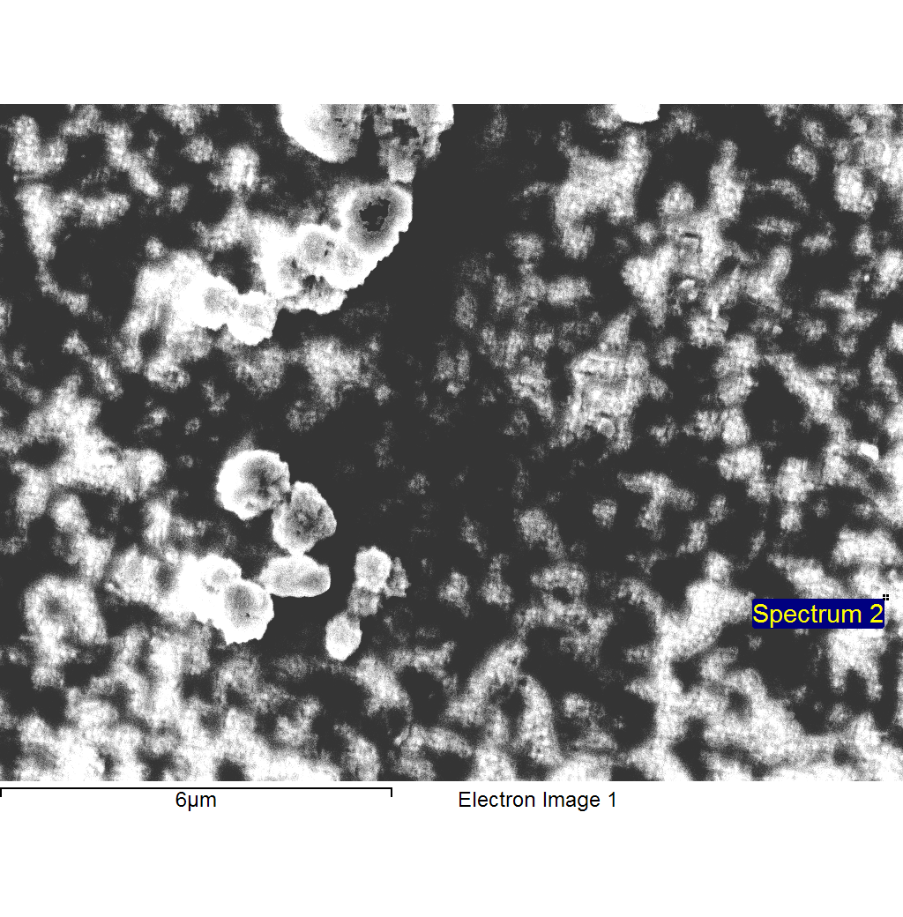
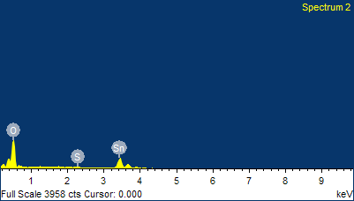
Project 1
1/17/2012 3:58:42 PM
Sample: Sample 5
Type: Default
ID: anneal nonsta

Comment:
Spectrum processing :
Peak possibly omitted : 1.745 keV

Processing option : All elements analyzed (Normalised)
Number of iterations = 3

Standard :
O SiO2 1-Jun-1999 12:00 AM
S FeS2 1-Jun-1999 12:00 AM
Sn Sn 1-Jun-1999 12:00 AM

Element | App | Intensity | Weight% | Weight% | Atomic%
 | Conc. | Corrn. |  | Sigma
O K | 35.63 | 1.3482 | 28.31 | 0.72 | 74.09
S K | 0.81 | 1.3157 | 0.66 | 0.19 | 0.86
Sn L | 55.49 | 0.8371 | 71.03 | 0.74 | 25.05
Totals |  |  | 100.00

